**What is SQL?**

SQL Overview: SQL stands for Structured Query Language. It is an American National Standard Institute (ANSI) standard. It is a standard language for accessing and manipulating databases. Using SQL, some of the action we could do are to create databases, tables, stored procedures (SP’s), execute queries, retrieve, insert, update, delete data against a database.

### ****What are the different types of SQL commands?****

SQL commands are segregated into the following types:

* DDL – Data Definition Language
* DML – Data Manipulation Language
* DQL – Data Query Language
* DCL – Data Control Language
* TCL – Transaction Control Language

**What are the different DDL commands in SQL?**

DDL commands are used to define or alter the structure of the database.

* CREATE: To create databases and database objects
* ALTER: To alter existing database objects
* DROP: To drop databases and databases objects
* TRUNCATE: To remove all records from a table but not its database structure
* RENAME: To rename database objects

**14. What are the different DML commands in SQL?**

DML commands are used for managing data present in the database.

* SELECT: To select specific data from a database
* INSERT: To insert new records into a table
* UPDATE: To update existing records
* DELETE: To delete existing records from a table

**15. What are the different DCL commands in SQL?**

DCL commands are used to create roles, grant permission, and control access to the database objects.

* GRANT: To provide user access
* DENY: To deny permissions to users
* REVOKE: To remove user access

**16. What are the different TCL commands in SQL?**

TCL commands are used to manage the changes made by DML statements.

* COMMIT: To write and store the changes to the database
* ROLLBACK: To restore the database since the last commit

### ****What is an Index?****

An index is used to speed up the performance of queries. It makes faster retrieval of data from the table. The index can be created on one column or a group of columns.

### ****What are all the different types of indexes?****

There are three types of indexes

**1. Unique Index:** Unique Indexes helps maintain data integrity by ensuring that no two rows of data in a table have identical key values. A unique index can be applied automatically when a primary key is defined. It ensures that the values in the index key columns are unique.  
**2. Clustered Index:** Clustered Index reorders the physical order of the table and search based on the key values. There will be only one clustered index per table.  
**3. Non-Clustered Index:** Non-Clustered Index doesn’t alter the physical order of the table and maintains a logical order of the data. Each table can have many non-clustered indexes.

### ****What is the difference between Cluster and Non-Cluster Index?****

The difference between the clustered and non-clustered index in SQL is as follows:  
**Clustered Index:**  
It is used for easy retrieval of data from the database and it is faster.  
One table can only have one clustered index  
It alters the way records are stored in a database as it sorts out rows by the column which is set to be clustered index.  
**Non-Clustered Index:**  
It is slower compared to the Clustered index.  
One table can have multiple non clustered index  
It doesn’t alter the way it was sorted but it creates a separate object within a table which points back to the original table rows after searching.

### ****What is a query?****

A database query is a request for data or information from a database table or combination of tables. A database query can be either a select query or an action query.

### ****24. What is a Subquery?****

A Subquery is a SQL query within another query. It is a subset of a Select statement whose return values are used in filtering the conditions of the main query.

### ****What is the difference between Rename and Alias?****

‘Rename’ is a permanent name given to a table or column  
‘Alias’ is a temporary name given to a table or column.

**What is a Join?**

Join is a query, which retrieves related columns or rows from multiple tables.

**34. What are the different types of joins?**

Types of Joins are as follows:

* INNER JOIN
* LEFT JOIN
* RIGHT JOIN
* OUTER JOIN

## **What is the difference between CHAR and VARCHAR2 datatype in SQL?**

Both Char and Varchar2 are used for characters datatype but varchar2 is used for character strings of variable length whereas Char is used for strings of fixed length. For example, char(10) can only store 10 characters and will not be able to store a string of any other length whereas varchar2(10) can store any length i.e 6,8,2 in this variable.

## **What is a Primary key?**

* 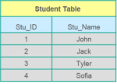APrimary keyis a column (or collection of columns) or a set of columns that uniquely identifies each row in the table.
* Uniquely identifies a single row in the table
* Null values not allowed

Example- In the Student table, Stu_ID is the primary key.

## **What are Constraints?**

Constraints are used to specify the limit on the data type of the table. It can be specified while creating or altering the table statement. The sample of constraints are:

* NOT NULL
* CHECK
* DEFAULT
* UNIQUE
* PRIMARY KEY
* FOREIGN KEY

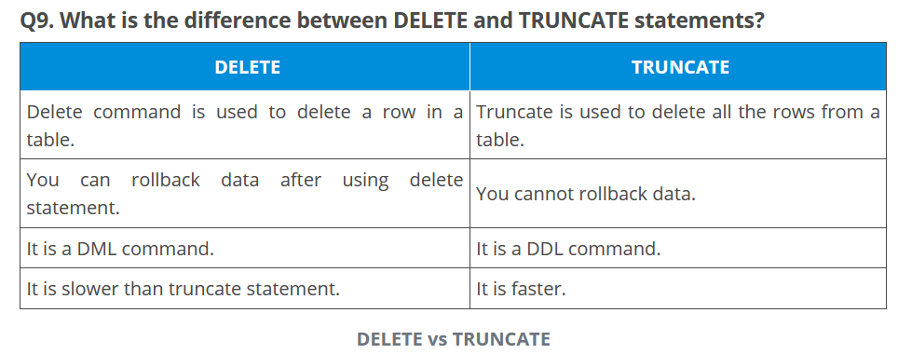

## **What is a Foreign key?**

* Foreign key maintains referential integrity by enforcing a link between the data in two tables.
* The foreign key in the child table references the primary key in the parent table.
* The foreign key constraint prevents actions that would destroy links between the child and parent tables.

## **What do you mean by data integrity?**

Data Integrity defines the accuracy as well as the consistency of the data stored in a database. It also defines integrity constraints to enforce business rules on the data when it is entered into an application or a database.

## **What do you mean by Denormalization?**

Denormalization refers to a technique which is used to access data from higher to lower forms of a database. It helps the database managers to increase the performance of the entire infrastructure as it introduces redundancy into a table. It adds the redundant data into a table by incorporating database queries that combine data from various tables into a single table.

## **What are Entities and Relationships?**

**Entities**:  A person, place, or thing in the real world about which data can be stored in a database. Tables store data that represents one type of entity. For example – A bank database has a customer table to store customer information. Customer table stores this information as a set of attributes (columns within the table) for each customer.

**Relationships**: Relation or links between entities that have something to do with each other. For example – The customer name is related to the customer account number and contact information, which might be in the same table. There can also be relationships between separate tables (for example, customer to accounts).

## **What is Normalization and what are the advantages of it?**

Normalization is the process of organizing data to avoid duplication and redundancy. Some of the advantages are:

* Better Database organization
* More Tables with smaller rows
* Efficient data access
* Greater Flexibility for Queries
* Quickly find the information
* Easier to implement Security
* Allows easy modification
* Reduction of redundant and duplicate data
* More Compact Database
* Ensure Consistent data after modification

## **What do you mean by “Trigger” in SQL?**

Trigger in SQL is are a special type of stored procedures that are defined to execute automatically in place or after data modifications. It allows you to execute a batch of code when an insert, update or any other query is executed against a specific table.

## **Are NULL values same as that of zero or a blank space?**

A NULL value is not at all same as that of zero or a blank space. NULL value represents a value which is unavailable, unknown, assigned or not applicable whereas a zero is a number and blank space is a character.

## **What is subquery in SQL?**

A subquery is a query inside another query where a query is defined to retrieve data or information back from the database. In a subquery, the outer query is called as the main query whereas the inner query is called subquery. Subqueries are always executed first and the result of the subquery is passed on to the main query. It can be nested inside a SELECT, UPDATE or any other query. A subquery can also use any comparison operators such as >,< or =.

## **What are the different types of a subquery?**

There are two types of subquery namely, Correlated and Non-Correlated.

**Correlated subquery**: These are queries which select the data from a table referenced in the outer query. It is not considered as an independent query as it refers to another table and refers the column in a table.

**Non-Correlated subquery**: This query is an independent query where the output of subquery is substituted in the main query.

**What is the need for group functions in SQL?**

Group functions work on the set of rows and returns one result per group. Some of the commonly used group functions are: AVG, COUNT, MAX, MIN, SUM, VARIANCE.

## **What is the main difference between ‘BETWEEN’ and ‘IN’ condition operators?**

BETWEEN operator is used to display rows based on a range of values in a row whereas the IN condition operator is used to check for values contained in a specific set of values.

**Why are SQL functions used?**

SQL functions are used for the following purposes:

* To perform some calculations on the data
* To modify individual data items
* To manipulate the output
* To format dates and numbers
* To convert the data types

## What do you mean by recursive stored procedure?

Recursive stored procedure refers to a stored procedure which calls by itself until it reaches some boundary condition. This recursive function or procedure helps the programmers to use the same set of code n number of times.

## **What is CLAUSE in SQL?**

SQL clause helps to limit the result set by providing a condition to the query. A clause helps to filter the rows from the entire set of records.

For example – WHERE, HAVING clause.

Apart from this SQL Interview Questions Blog, if you want to get trained from professionals on this technology, you can opt for a structured training from edureka! Click below to know more.

## **Q41. What is the difference between ‘HAVING’ CLAUSE and a ‘WHERE’ CLAUSE?**

HAVING clause can be used only with SELECT statement. It is usually used in a GROUP BY clause and whenever GROUP BY is not used, HAVING behaves like a WHERE clause.   
Having Clause is only used with the GROUP BY function in a query whereas WHERE Clause is applied to each row before they are a part of the GROUP BY function in a query.

## What are aggregate and scalar functions?

Aggregate functions are used to evaluate mathematical calculation and returns a single value. These calculations are done from the columns in a table. For example- max(),count() are calculated with respect to numeric.

Scalar functions return a single value based on the input value. For example – UCASE(), NOW() are calculated with respect to string.

## How can you fetch alternate records from a table?

You can fetch alternate records i.e both odd and even row numbers. For example- To display even numbers, use the following command:

Select studentId from (Select rowno, studentId from student) where mod(rowno,2)=0

Now, to display odd numbers:

Select studentId from (Select rowno, studentId from student) where mod(rowno,2)=1

**Name the operator which is used in the query for pattern matching?**

LIKE operator is used for pattern matching, and it can be used as -.

1. % – It matches zero or more characters.

For example- select * from students where studentname like ‘a%’

_ (Underscore) – it matches exactly one character.  
For example- select * from student where studentname like ‘abc_’

## **What is a View?**

A view is a virtual table which consists of a subset of data contained in a table. Since views are not present, it takes less space to store. View can have data of one or more tables combined and it depends on the relationship.

## **Q55. What are Views used for?**

A view refers to a logical snapshot based on a table or another view. It is used for the following reasons:

* Restricting access to data.
* Making complex queries simple.
* Ensuring data independence.
* Providing different views of same data.

## Q56. What is a Stored Procedure?

A Stored Procedure is a function which consists of many SQL statements to access the database system. Several SQL statements are consolidated into a stored procedure and execute them whenever and wherever required which saves time and avoid writing code again and again.

## List some advantages and disadvantages of Stored Procedure?

### ****Advantages****:

A Stored Procedure can be used as a modular programming which means create once, store and call for several times whenever it is required. This supports faster execution. It also reduces network traffic and provides better security to the data.

### ****Disadvantage****:

The only disadvantage of Stored Procedure is that it can be executed only in the database and utilizes more memory in the database server.

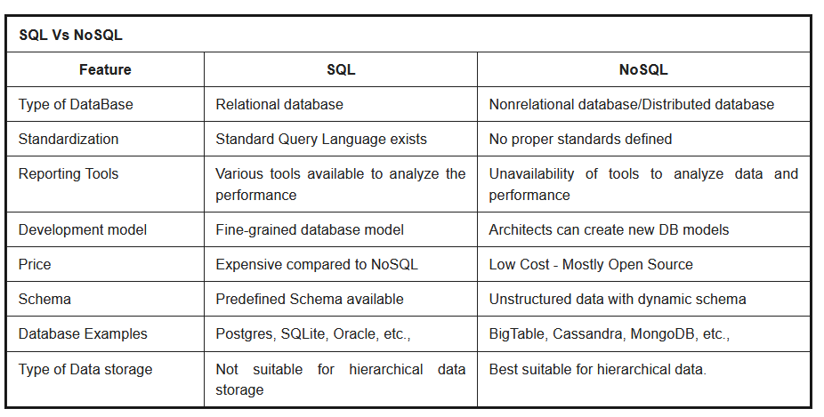

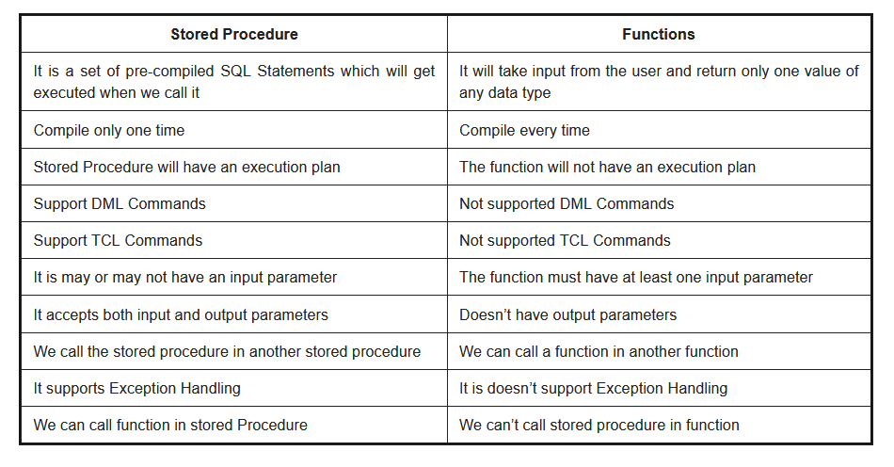

**Tell something about the Temp Table?**

**Ans:** It is basically a structure in the SQL that is sued for storing any sort of data that is not permanent or need to be stored for a specific time period. Depending on the needs, it is possible to extend the space up to any extend. Generally, limited space is kept reserved as the temp table.

**What is the significance of the default constraint in SQL?**

**Ans:** It is used when it comes to including a default value in a column in case there is no new value provided at the time a record is inserted.

**What are the factors that can affect the functionality of a database according to you?**

**Ans:** There are certain things that largely matters. The first and the foremost is nothing but the size of the database in terms of its storing capacity. Of course, for a bigger database, the needs are complex and so does its management.

Thus, the first thing that can help to keep up the pace in this matter is a powerful query language or a controlling procedure. Next thing is the security of the database. In addition to this, the experience of the experts handling the important operations can also largely impact the database. Moreover, there are conditions on the operation of the same that also largely matter.

**What is SQL?**

**Ans:** [SQL](https://mindmajix.com/sql)- A Structured Query Language, It is also pronounced as “SEQUEL” and it a Non-procedural Language which is used to operate all relational database. Used for Database communication. Its a standard language that can be used to perform the tasks like data retrieval, data update, insert or delete data from a database.

***Features of SQL:***

* Portability
* Client-server architecture,
* Dynamic data definition,
* Multiple views of data,
* Complete database language,
* Interactive,
* High level,
* Structure and SQL standards.

**What are SQL Injections? And How to Prevent SQL Injection Attacks?**

**Ans:** It is a mechanism of getting secure data from the database.

**SQL Injection Attacks::**

* By providing proper validations for input fields.
* By using parameterized queries.
* By using stored procedures
* By using frequent code reviews
* We must not display database error messages in frontend
* An SQL injection is a code injection technique, used to attack data-driven applications.

#### **What is a trigger?**

**Answer:** Triggers are stored programs that get automatically executed when an event such as INSERT, DELETE, UPDATE(DML) statement occurs. Triggers can also be evoked in response to Data definition statements(DDL) and database operations, for example, SERVER ERROR, LOGON.

#### **What is SAVEPOINT in a transaction control**

**Answer:** A SAVEPOINT is a point in a transaction when you can roll the transaction back to a certain point without rolling back the entire transaction.